Changing VaR and CVaR Quantiles
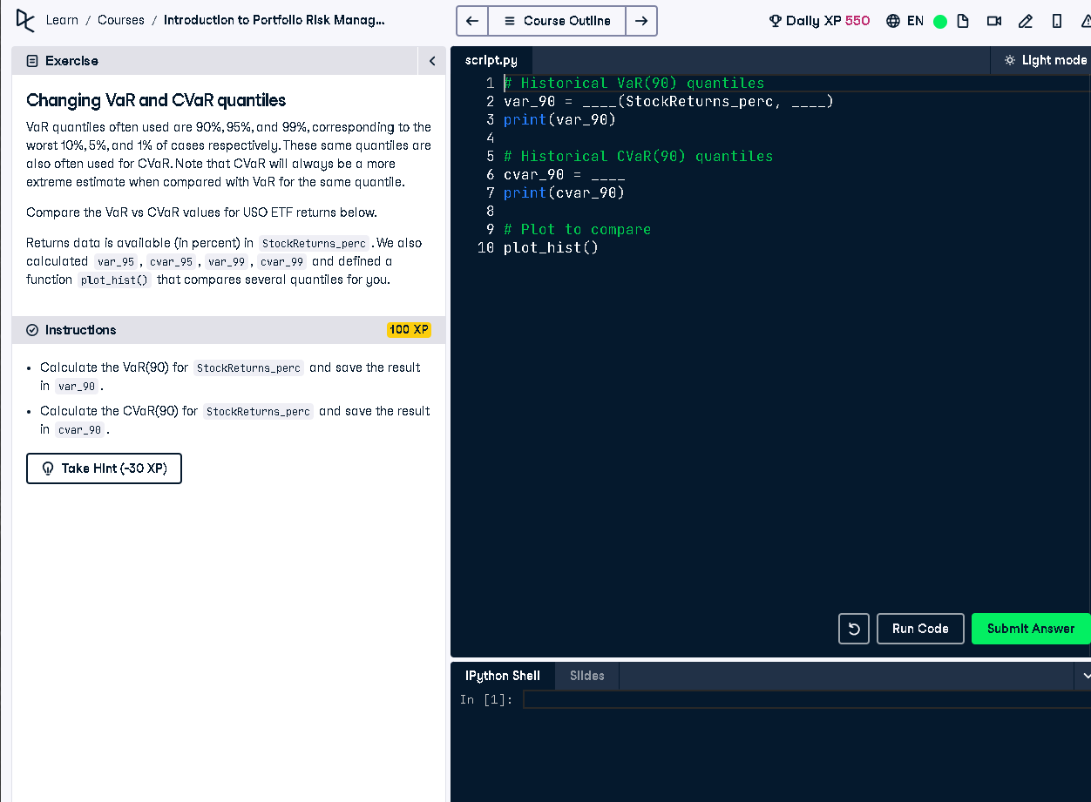

Python Code
# Historical VaR(90) quantiles
var_90 = np.percentile(StockReturns_perc, 10)
print(var_90)
# Historical CVaR(90) quantiles
cvar_90 = StockReturns_perc[StockReturns_perc <= var_90].mean()
print(cvar_90)
# Plot to compare
plot_hist()

Explanation
This code calculates the 90% quantile VaR and CVaR. VaR(90) represents the threshold below which the worst 10% of losses occur. CVaR(90) is the average of those worst 10% returns. The plot_hist() function visualizes the results to compare quantile thresholds clearly.

